**Project Name: How to create a reel design using canva**

**Team ID:** NM2023TMID06426

**Team Leader Name:**

B.KarthigaiLakshmi(8DBE97D3947F7489169454A13484BAEE)

**Team Members:**

K.Kavipriya(2B6881C017A4062826340835044A80A7)

M.Sneha(E042423BD09C7D386644F72D72BE85C0)

S.Sutharshini(9150D0CA2518A6AB7584DFB00C6D2C79)

**Introduction**

Overview

Food trucks have gained popularity due to their flexibility, serving locations that range from street corners and festivals to office parks and special events. They offer an array of foods, from traditional dishes to creative fusions, providing an experience that caters to various tastes and dietary preferences. The trend has expanded globally, with food trucks becoming a prominent part of urban food culture, fostering culinary innovation and providing opportunities for chefs and entrepreneurs to showcase their culinary skills in a more accessible and affordable way.

Purpose

Food trucks serve a multitude of purposes in today's culinary landscape. They act as mobile hubs of culinary innovation, offering accessibility to diverse and often unique food options. Not only do they provide quick, on-the-go meals for busy individuals, but they also serve as platforms for aspiring chefs and entrepreneurs to showcase their talents with lower initial investment costs. Moreover, these trucks contribute to community engagement, becoming integral parts of local events and festivals, while also enriching the overall culinary diversity by introducing novel flavors and fusions to eager customers.

**Result**

Food trucks have become essential in today's culinary scene, serving a multitude of purposes. They act as mobile hubs of culinary innovation, offering convenient access to diverse and unique food options. Not only do they provide quick, on-the-go meals for busy individuals, but they also serve as platforms for aspiring chefs and entrepreneurs to showcase their talents with lower initial investment costs.

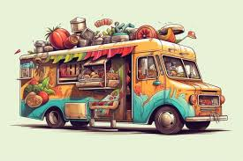

Additionally, these trucks contribute to community engagement, becoming integral parts of local events and festivals. They enrich the overall culinary landscape by introducing novel flavour and fusions to eager customers, fostering a culture of culinary diversity.

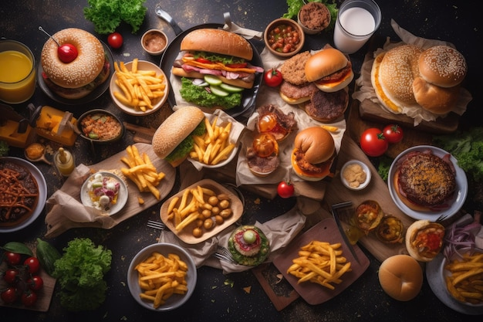

**Advantages For Truck food:**

* Mobility: They can easily relocate to different areas or events, reaching diverse customer bases, and adapting to changing demands.
* Lower Costs: Compared to traditional brick-and-mortar restaurants, food trucks generally have lower initial investment and operating costs, making them an attractive option for entrepreneurs.
* Culinary Innovation: Food trucks are known for their creativity, often offering unique and innovative dishes that might not be found in standard eateries.
* Community Engagement: They contribute to local events and gatherings, becoming integral parts of community culture and offering a sense of togetherness.
* Flexibility: Food trucks can experiment with their menus and adapt quickly to cater to dietary trends and preferences, offering a diverse range of cuisines.
* Quick Service: They provide fast and efficient service, catering to people looking for a quick meal without compromising on taste and quality.

**Disadvantages For Truck food:**

* Weather Dependence: Outdoor operations make food trucks vulnerable to weather conditions, affecting business during inclement weather.
* Limited Space: The confined space within a food truck can limit the menu options and the number of staff working, impacting the range and speed of service.
* Regulatory Hurdles: Navigating various local regulations, permits, and parking restrictions can be complex, adding administrative burdens and sometimes limiting where they can operate.
* Seasonal Demand: Business might fluctuate seasonally, being more dependent on certain events, weather, or specific times of the year.
* Maintenance and Upkeep: Ensuring the proper maintenance and upkeep of the mobile kitchen and equipment can be more challenging compared to a stationary restaurant.
* Competition and Location: With the increasing popularity of food trucks, competition can be high, and finding the right locations or events to maximize sales can be a continuous challenge.

**Application:**

Food trucks find versatile applications across several domains. Primarily, they serve as launch pads for culinary entrepreneurs, offering a feasible entry into the food industry with lower initial investment. Additionally, these mobile kitchens cater to events, ranging from local festivals to large-scale weddings and corporate gatherings, adding a distinctive and diverse culinary experience. Their participation in community events fosters a sense of unity and engagement within local neighbourhoods. Moreover, food trucks contribute significantly to the culinary scene, introducing innovative and varied cuisines that enrich the gastronomic landscape. Some trucks even transcend food services, doubling as mobile retail outlets, showcasing products or services while providing a point of contact for businesses. The adaptability and mobility of these trucks enable their multifaceted application, from entrepreneurial ventures to community engagement and culinary exploration.

**Conclusion:**

Food trucks stand as dynamic entities within the culinary world, offering a diverse array of advantages, from fostering entrepreneurial opportunities with lower investment costs to contributing innovative culinary experiences to events and communities. Despite their challenges, such as weather dependency and regulatory hurdles, their adaptability and mobility empower them to serve as more than just mobile eateries. These trucks symbolize a convergence of entrepreneurship, community engagement, and culinary innovation, amplifying the gastronomic landscape while providing unique and accessible dining experiences. Their continued presence and evolving nature affirm their crucial role in shaping the modern culinary scene, showcasing creativity on wheels while enriching the palates and experiences of their patrons.

**Instagram ID**:

https://www.instagram.com/reel/Cy8kxbILaUS/?igshid=MzRlODBiNWFlZA==